**Problem 1: Find the total number of crimes recorded in the Crime table**Take a screenshot showing the SQL query and its results. Upload the JPEG (.jpg) file below for your peers to review.

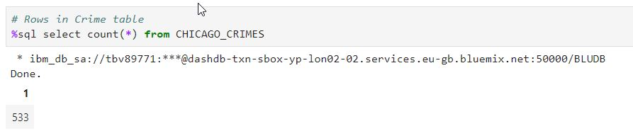

**Problem 2: Retrieve first 10 rows from the CRIME table** Take a screenshot showing the SQL query and its results. Upload the JPEG (.jpg) file below for your peers to review.

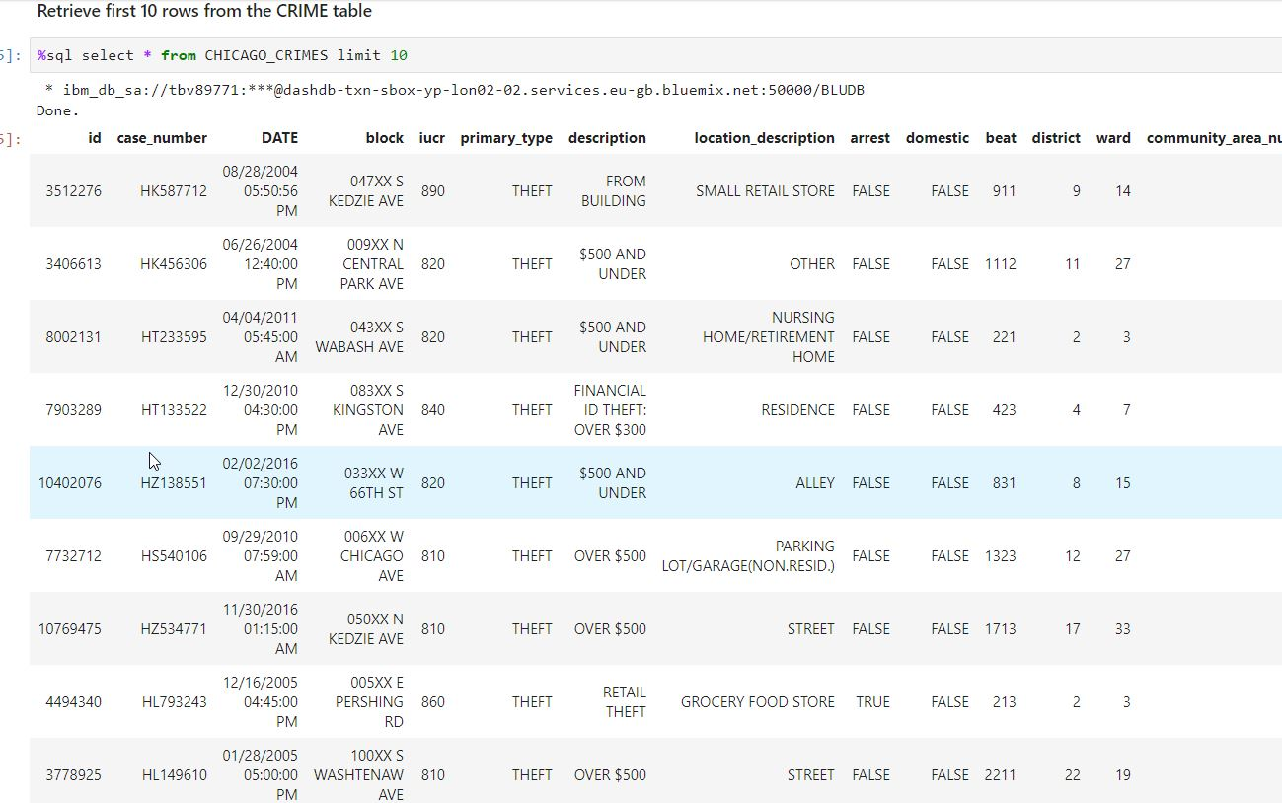

**Problem 3: How many crimes involve an arrest** Take a screenshot showing the SQL query and its results. Upload the JPEG (.jpg) file below for your peers to review.

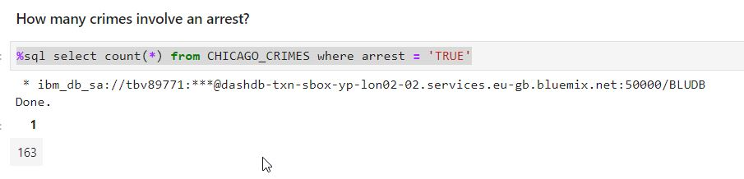

**Problem 4: Which unique types of crimes have been recorded at a GAS STATION?** Take a screenshot showing the SQL query and its results. Upload the JPEG (.jpg) file below for your peers to review.

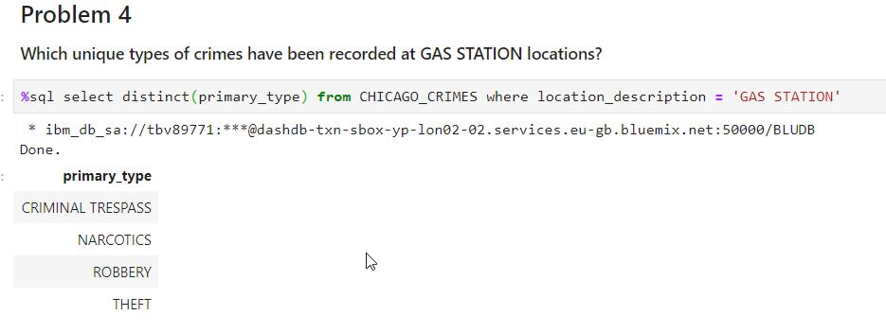

**Problem 5: In the CENUS_DATA table list all community areas whose names start with the letter ‘B’.** Take a screenshot showing the SQL query and its results. Upload the JPEG (.jpg) file below for your peers to review.

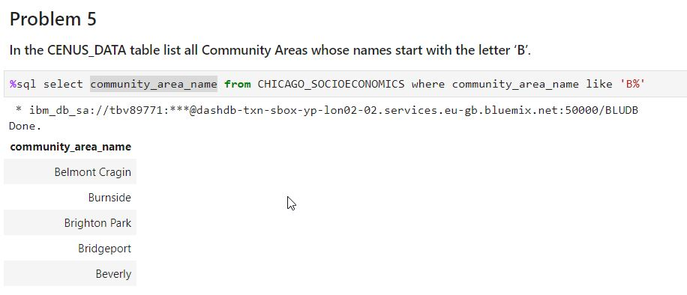

**Problem 6: List the schools in Community Areas 10 to 15 that are healthy school certified?** Take a screenshot showing the SQL query and its results. Upload the JPEG (.jpg) file below for your peers to review.

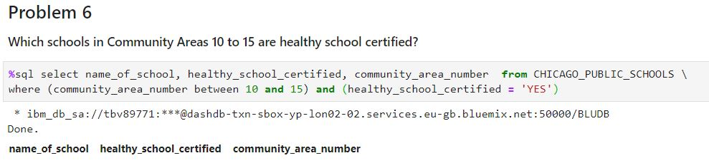

**Problem 7: What is the average school Safety Score?** Take a screenshot showing the SQL query and its results. Upload the JPEG (.jpg) file below for your peers to review.

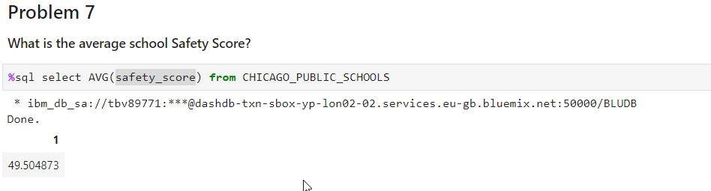

**Problem 8: List the top 5 Community Areas by average College Enrollments [number of students]** Take a screenshot showing the SQL query and its results. Upload the JPEG (.jpg) file below for your peers to review.

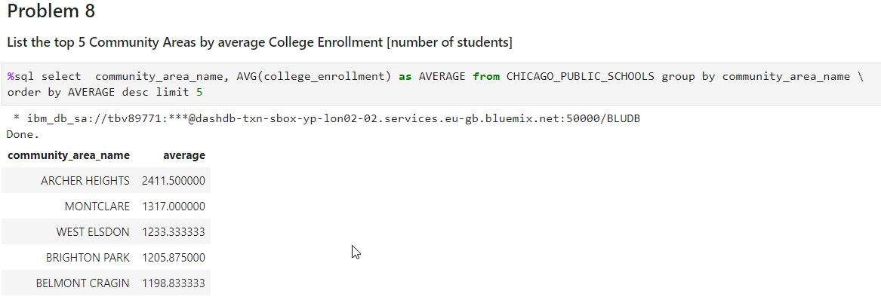

**Problem 9: Use a sub-query to determine which Community Area has the least value for Safety Score?** Take a screenshot showing the SQL query and its results. Upload the JPEG (.jpg) file below for your peers to review.

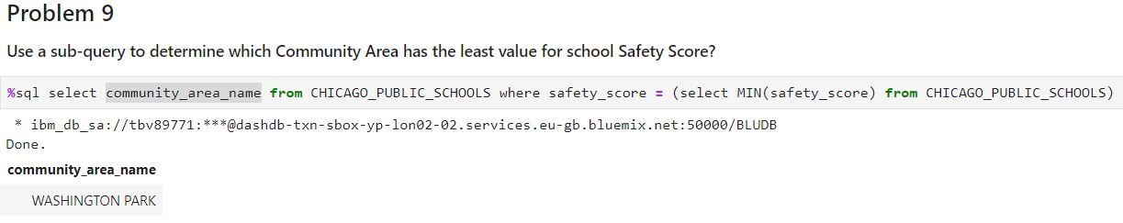

**Problem 10: Find the Per Capita Income of the Community Area which has a school Safety Score of 1.** Take a screenshot showing the SQL query and its results. Upload the JPEG (.jpg) file below for your peers to review.

